Name | Swayam Ramdin
Roll no | 24204B0061
Batch | 03
Subject name | Python Programming & Data Structure
Teacher Name | Ms. Rasika Patil

Experiments | 11
Title | *a) Develop python program to demonstrate use of NumPy package for creating, accessing and performing different array operations.  *b) Develop program to demonstrate the use of user defined packages in python.
Practical significance
NumPy can be used to perform a wide variety of mathematical operations on arrays. It adds powerful data structures to Python that guarantee efficient calculations with arrays and matrices and it supplies an enormous library of high- level mathematical functions that operate on these arrays and matrices.

Relevant Theoretical Background
NumPy stands for "Numerical Python". It provides a high-performance multidimensional array object, and tools for working with these arrays. An array is a table of elements (usually numbers), all of the same type, indexed by a tuple of positive integers and represented by a single variable. NumPy's array class is called ndarray.
It is also known by the alias array. In NumPy arrays, the individual data items are called elements. All elements of an array should be of the same type. Arrays can be made up of any number of dimensions. In NumPy, dimensions are called axes. Each dimension of an array has a length which is the total number of elements in that direction.

The size of an array is the total number of elements contained in an array in all the dimension. The size of NumPy arrays are fixed; once created it cannot be changed again.

Numpy arrays are great alternatives to Python Lists. Some of the key advantages of Numpy arrays are that they are fast, easy to work with, and give users the opportunity to perform calculations across entire arrays.
- Creating Numpy: To create a NumPy use ndarray object by using the array() function. Install Numpy by using a python library called pip by using the command :
pip install numpy .
To use NumPy you need to import Numpy:
import numpy as np # alias np
- Accessing and performing different array operations: Example 1: For NumPy with array object.
import numpy as np
a=np.array([1,2,3]) # one dimensional array print(a)
Output:
[1 2 3]
Example 2:
arr=np.array([[1,2,3],[4,5,6]]) # two dimensional array print(arr)
Output:
[[1 2 3]
[4 5 6]]
Example 3:
arr=np.array([[1,2,3],[4,5,6]]) a=arr.reshape(3,2)
print(a)
array([[1, 2], [3,4], [5,6]])

Programming Questions with Answer
1 | Write a Python NumPy program to create a 3x3 identity matrix.
SCRIPT | import numpy as np  identity_matrix = np.eye(3)  print(identity_matrix)
OP | 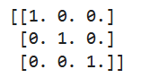
2 | Write a Python NumPy program to create a 4x4 matrix with values ranging from 2 to 10.
SCRIPT | import numpy as np  matrix = np.arange(2, 18).reshape(4, 4)  print(matrix)
OP | 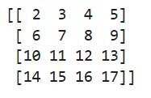
3 | Program to create a user-defined package  Step 1 — Folder Structure  Step 2 — ops.py  Step 3 — Main Program
SCRIPT | import os  os.makedirs("mypackage", exist_ok=True)  open("mypackage/__init__.py", "w").close()  %%writefile mypackage/ops.py  def add(a, b):  return a + b  def multiply(a, b):  return a * b  from mypackage import ops  print("Addition:", ops.add(5, 3))  print("Multiplication:", ops.multiply(5, 3))
OP | 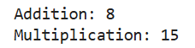
Debugging Questions with Corrected Answers
1 | Debug the following code  Wrong code:  import numpy  a = numpy.array[1, 2, 3]  print(a)
OP | Error: 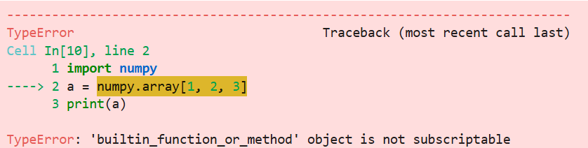  Correct code:  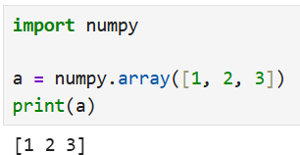
2 | Debug the following code  Wrong code:  from mypackage import add  print(add(3, 2))
OP | Error: 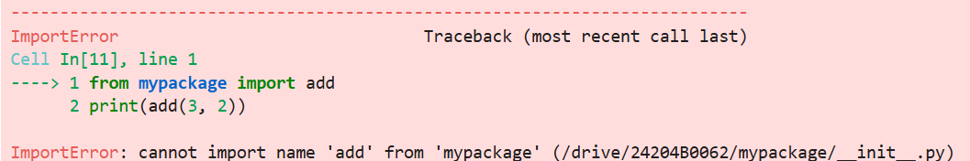  Correct code:  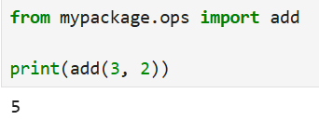
Conclusion

Performance Indicators |  | Teachers Dated and Signature
Process Related  (15 M) | Product Related  (10 M) | Total (25 M)

